B

# Special Mangum Utility Authority Meeting

**January 24, 2023 at 10:00 AM,** *or immediately following City Commission*

*City Administration Building at 130 N Oklahoma Ave.*

# Record of Minutes

*The Trustees of the Mangum Utility Authority will meet in special session on January 24, 2023, immediately following the City of Mangum Commission meeting for such business as shall come before said Trustees.*

## CALL TO ORDER

Mayor Scott called the meeting to order at 10:40am. **ROLL CALL AND DECLARATION OF QUORUM** PRESENT

Chairman Mary Jane Scott

Trustee Dale Burnam Trustee Mark Chapman Trustee Dixie Peterson

ABSENT

Trustee Larry Miller

## OTHER ITEMS

1. Discussion and possible action with regard to reviewing the lnterlocal Agreement for the Operation of Emergency Medical Services between the City of Mangum, the Mangum Utility Authority, and the Greer County Special Ambulance District. The Agreement provides that the Ambulance District must (1) provide a financial audit within 90 days of the conclusion of its financial year indicating no material weaknesses or substantial deficiencies; and (2) provide proof that it has raised sufficient and proportional revenues from Greer County and additional communities to properly fund the Ambulance District. Failure to satisfy either point allows for termination of this Agreement effective February 1, 2023.

Motion to approve.

Motion made by Commissioner Peterson, Seconded by Commissioner Chapman. Voting Yea: Chairman Scott, Commissioner Burnam, Commissioner Chapman, Commissioner

Peterson.

Presentation given by Landon Brooks on the EMS agreement with the City and all the benefits and good it will do for the community. Talked about the audit and the revenues and the future with the contract.

**Special Mangum Utility Authority Meeting January 24, 2023**

**Minutes** Page 1 of 2

B

1. Discussion and possible action with regard to renewing the lnterlocal Agreement for the

Operation of Emergency Medical Services. The lnterlocal Agreement must be renewed by February 1, 2023. If not, it expires on June 30, 2023. The lnterlocal Agreement allows the City of Mangum to collect a $12.00 fee on residential meters within the corporate city limits to the City of Mangum for the operation of the Ambulance District.

Motion to approve renewal of the lnterlocal agreement.

Motion made by Commissioner Peterson, Seconded by Commissioner Chapman. Voting Yea: Chairman Scott, Commissioner Burnam, Commissioner Chapman, Commissioner Peterson

## ADJOURN

*Motion to Adjourn*

Motion to adjourn at 10:45am.

Motion made by Trustee Chapman, Seconded by Trustee Peterson.

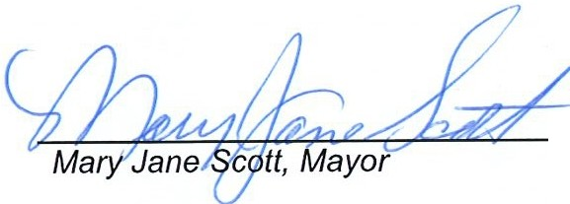Voting Yea: Chairman Scott, Trustee Burnam, Trustee Chapman, Trustee Peterson

~~'""mm~~,.,,, @tu B

li,&f:Csb._

,,,' i )I!.*; :ma Mora, City Clerk*

**§'$./·o•' flCJ,q';---...**

***:***'***::(!Jl***... ' ..·.. •***·r-***,O

s =*l*-··,**SEAL.y-at-i**

· *..* /

" ., ,,...

**0** , ,,,,

*;J-<*

·*\*:::*

*"11,,,* **LAHO ,,,,-.**

**,,,,,,,11111\\\\\**

**Special Mangum Utility Authority Meeting January 24, 2023**

**Minutes** Page 2 of 20